TEACHING ENGLISH VOCABULARY BY MEANS OF THE MODERN LEARNING METHODD
THE JIGSAW
TEXTBOOK: MISSION 2
FORM : 10th
LESSON: AUDREY HEPBURN

I divide students into 4 groups of 4 and appoint one student from each group as the leader. Initially, this person should be the most mature student in the group. I divide the lesson “Audrey Hepburn” into 4 segments and assign each student to learn one segment, making sure students have direct access only to their own segment. –her appearance –her clothes –major films – people who influenced her
Task : Students have to read their segment at least twice and become familiar with it. They form temporary "expert groups" by having one student from each jigsaw group join other students assigned to the same segment. Students in these expert groups have time to discuss the main points of their segment and to rehearse the presentations they will make to their jigsaw group. I ask each student to present her or his segment to the group and encourage others in the group to ask questions for clarification. They float from group to group, observing the process. If any group is having trouble (e.g., a member is dominating or disruptive), I make an appropriate intervention. Eventually, it's best for the group leader to handle this task. Leaders can be trained by whispering an instruction on how to intervene, until the leader gets the hang of it.At the end of the session, I give a quiz on the material so that students quickly come to realize that these sessions are not just fun and games but really count.

WORKSHEET
The Jigsaw - Audrey Hepburn
Group 1 – choose words and expressions from the text and then the experts discuss about them

Her appearance 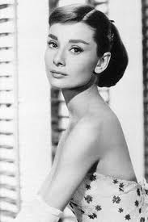
........................................................................................

Group 2 – choose from the text words related to clothes and discuss about her style
Her clothes
.............................................................................................................
Group 3 – Ss skip he text and select names of films she acted and add extra information about each of them using other sources (ex. the internet)
Major films
Group 4 – Ss look for information about people who influence A. Hepburn’ life
Important people

The Jigsaw - Audrey Hepburn
Group 1 – choose words and expressions from the text and then the experts discuss about them

Her appearance
“elf-like face”,
“ballerina-thin figure”,
“the envy of a new generation of women”
“Audrey…not looked like a girls’ girl, she dressed like one”

Group 2 – choose from the text words related to clothes and discuss about her style
Her clothes
“natural fashion sense and passion for clothes”
“ballet pumps, little dresses and narrow black trousers”
“black polo necks, simple raincoats, full skirts gathered at the waist”
“black trousers with shiny loafers”
“superbly tailored suits with boxy jackets and calf-length skirts”

Group 3 – Ss skim the text and select the names of the films she acted and add extra information about each of them using other sources (ex. the internet)
Major films
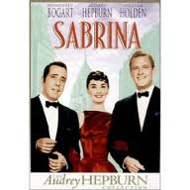 | 1954, directed by Billy Wilder  -lighthearted romantic comedy Sabrina, based on the play by Samuel A. Taylor. Sabrina Fairchild (Audrey Hepburn) is the simple, naïve daughter of a chauffeur, Thomas Fairchild (John Williams). They live on an estate with the wealthy Oliver Larrabee (Walter Hampden) and his two sons: workaholic older brother Linus (Humphrey Bogart) and fun-loving younger brother David (William Holden). Sabrina adores the charming David, but he thinks of her as just a kid. etc
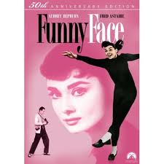 | 1957, directed by Stanley Donen  -A charming yet relatively generic musical, Funny Face was a huge success upon its release in 1957, and is now a celebrated classic. Starring the captivating Audrey Hepburn and the debonair Fred Astaire, this bright and picturesque film features many unforgettable songs and amazingly choreographed dance sequences with the incredibly talented cast.
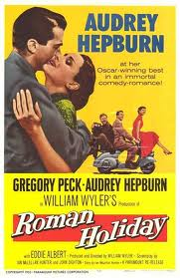 | 1953- a delightful, captivating story shot in Rome  -produced and directed by one of Hollywood’s most skillful and professional directors- William Wyler  -The film's bittersweet story is a charming romantic-comedy, a kind of Cinderella tale in reverse (with an April-October romance). A runaway princess (Hepburn) rebels against her royal obligations and escapes the insulated confines of her royal prison to find a 'Prince Charming' commoner - an American reporter (Peck) covering the royal tour in Rome. The story was reportedly based on the real-life Italian adventures of British Princess Margaret.
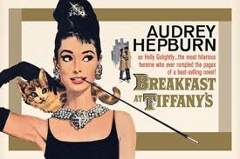 | 1961- Paramount Pictures  - romantic comedy  -a young New York socialite becomes interested in a young man who has moved into her apartment building.  - A. H. was the better choice, simply because her physical appearance already resembled the thin “chicness” of Holly and her accent was perfect for the part
Group 4 – Ss look for information about people who influence A. Hepburn’ life
Hubert de Givenchy  (French designer) | -made her an A-list star  -she looked so “breathtakingly beautiful”  Style: “clinging black evening dresses”, “bare-shouldered evening dress”
Edith Head  (Hollywood costume designer) | -won an Oscar for her efforts  Style: “flat shoes, gathered cotton skirts and plain blouses with the sleeves rolled up”

